Updated 1/7/24

Pink - MS/HS Snow & Emergency Route

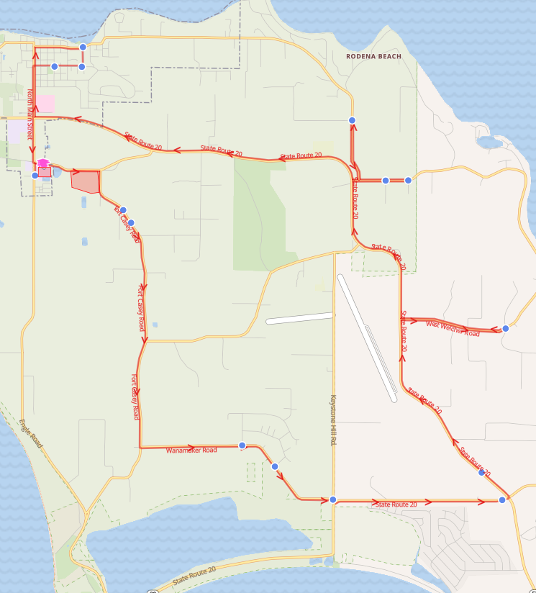

Pink - MS/HS Snow & Emergency Route

Reg Start 2- Hr. Delay
7:01 AM | 9:01 AM | 217 Fort Casey Rd
7:01 AM | 9:01 AM | 259 Fort Casey Rd
7:08 AM | 9:08 AM | Wanamaker Rd & Prairie View Ave
7:09 AM | 9:09 AM | Wanamaker Rd & Ferry Ave
7:13 AM | 9:13 AM | Keystone Hill Rd & Wanamaker Rd
7:15 AM | 9:15 AM | Hwy 20 & Hwy 525 (Park and Ride)
7:16 AM | 9:16 AM | Hwy 20 & Center Point Church
7:21 AM | 9:21 AM | Welcher Rd & Hobart Rd
7:26 AM | 9:26 AM | Morris Rd & Meadowlark Rd
7:27 AM | 9:27 AM | Morris Rd & Fox Hollow Dr
7:31 AM | 9:31 AM | Parker Rd & Plum Creek Ln
7:39 AM | 9:39 AM | Otis St & 9th St
7:40 AM | 9:40 AM | 6th St & Otis St (Church Driveway)
7:41 AM | 9:41 AM | 6th St & Kinney St

Pink - Elementary Snow & Emergency Route

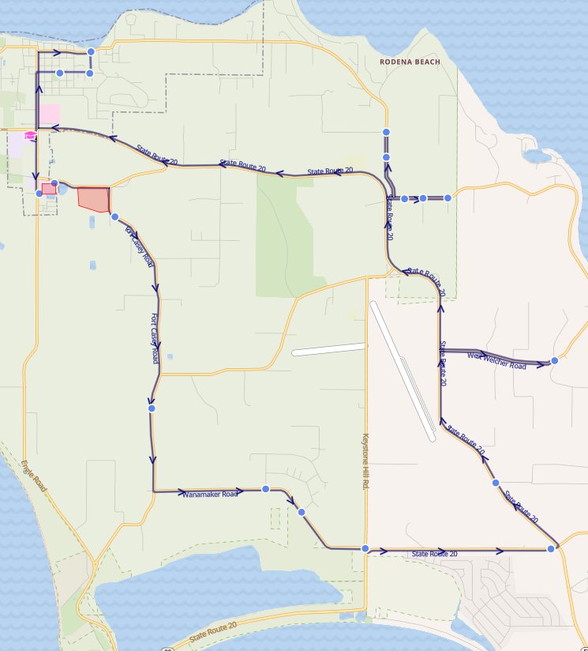

Pink - Elementary Snow & Emergency Route

Reg Start 2- Hr. Delay
8:01 AM | 10:01 AM | 186 Fort Casey Rd
8:04 AM | 10:04 AM | 710 Fort Casey Rd
8:08 AM | 10:08 AM | Wanamaker Rd & Prairie View Ave
8:09 AM | 10:09 AM | Wanamaker Rd & Ferry Ave
8:13 AM | 10:13 AM | Keystone Hill Rd & Wanamaker Rd
8:15 AM | 10:15 AM | Hwy 20 & Hwy 525 (Park and Ride)
8:19 AM | 10:19 AM | Hwy 20 & Squire Rd
8:23 AM | 10:23 AM | Welcher Rd & Hobart Rd
8:27 AM | 10:27 AM | 305 Morris Rd
8:28 AM | 10:28 AM | Morris Rd & Meadowlark Rd
8:28 AM | 10:28 AM | Morris Rd & Fox Hollow Dr
8:30 AM | 10:30 AM | Pacific Rim (ECEAP)
8:31 AM | 10:31 AM | Parker Rd & Plum Creek Ln
8:40 AM | 10:40 AM | Otis St & 9th St
8:41 AM | 10:41 AM | 6th St & Otis St (Church Driveway)
8:42 AM | 10:42 AM | 6th St & Kinney St

